Experiment 8
Code: insertion sort
#include <iostream>
#include<conio.h>
using namespace std;
int main() {
int n;
cout << "Enter number of elements: ";
cin >> n;
int* arr = new int[n];
cout << "Enter " << n << " elements:\n";
for (int i = 0; i < n; i++)
cin >> arr[i];
for (int i = 1; i < n; i++) {
int key = arr[i];
int j = i - 1;
while (j >= 0 && arr[j] > key) {
arr[j + 1] = arr[j];
j--;
}
arr[j + 1] = key;
}
cout << "Sorted array: ";
for (int i = 0; i < n; i++)
cout << arr[i] << " ";
cout << endl;
delete[] arr;
_getch();
}

Output:
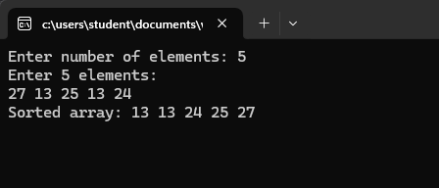

Experiment 8
Code : heap sort
#include <iostream>
#include<conio.h>
using namespace std;
void heapify(int arr[], int n, int i) {
int largest = i;
int left = 2 * i + 1;
int right = 2 * i + 2;
if (left < n && arr[left] > arr[largest])
largest = left;
if (right < n && arr[right] > arr[largest])
largest = right;
if (largest != i) {
swap(arr[i], arr[largest]);
heapify(arr, n, largest);
}
}
void heapSort(int arr[], int n) {
for (int i = n / 2 - 1; i >= 0; i--)
heapify(arr, n, i);
for (int i = n - 1; i >= 0; i--) {
swap(arr[0], arr[i]);
heapify(arr, i, 0);
}
}
void printArray(int arr[], int n) {
for (int i = 0; i < n; i++)
cout << arr[i] << " ";
cout << endl;
}
int main() {
int n;
cout << "Enter number of elements: ";
cin >> n;
int* arr = new int[n];
cout << "Enter " << n << " elements:\n";
for (int i = 0; i < n; i++)
cin >> arr[i];
heapSort(arr, n);
cout << "Sorted array: ";
printArray(arr, n);
delete[] arr;
_getch();
}
Output:
